**Peregrine Aubrey, Devon**

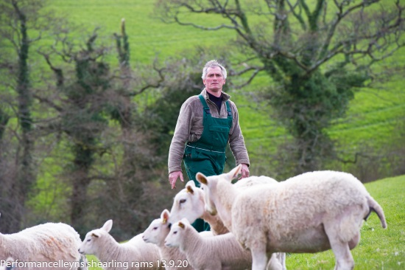Our aim at Performance Lleyns is to provide Lleyn sheep for sale to the commercially minded farmer who expects the best possible performance from a maternal sheep, which are as capable of breeding female replacements as producing finished lamb.

We have the highest indexed flock of Lleyns in the UK and are looking at introducing New Zealand genes in the quest to breed the Ultimate self-replacing ewe.

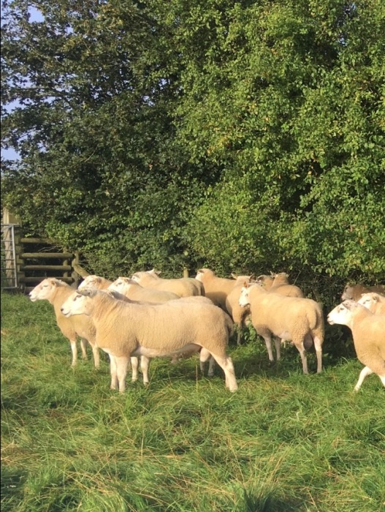**Trevor and Chere Border, Rutland**

Leighfeild Lleyns is an all grass/outdoor lambing system. The ewes lamb during the last week of April and into May. The pedigree flock of 240 ewes run alongside 2000 commercially run Lleyn ewes, all sheep are run as one fit, healthy flock with no additional feeds used. We use our Signet records to hopefully create a strong animal which has two lambs, lambs in all weathers and with minimum input.

**Edward Collins, Herefordshire**

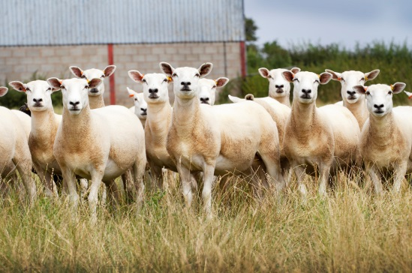

The Lleyn flock at Bearwood has used performance recording and genetics for over 20 years to breed sheep that will perform off a grass based diet. Breeding sheep are sold to commercial and pedigree producers throughout the UK. 

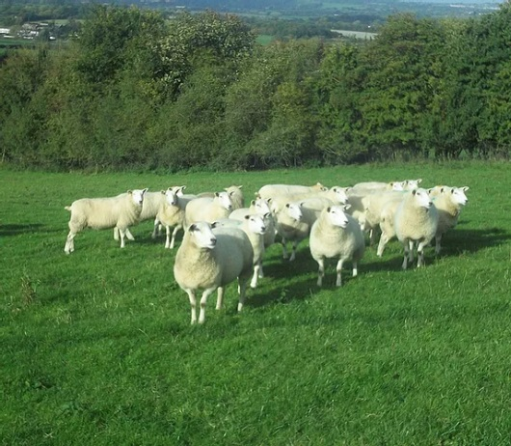**George Cullimore, Somerset**

Concentrating on performance recording in a commercial system we aim to produce resilient sheep that will thrive in less than optimal conditions. All ewes are lambed outside in March and April. We are particularly focused on maternal traits and breeding for worm resistance. The flock is MV accredited and we sell to both pedigree and commercial customers.

**Sue and Richard Evans, Norfolk**

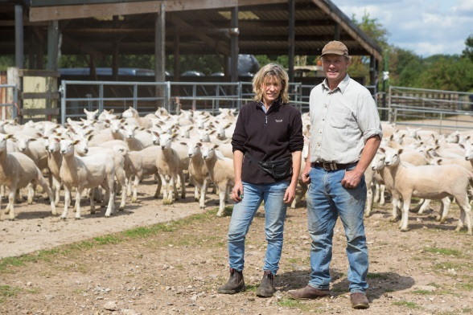We've both kept a few sheep over the years , and sixteen years ago we decided to buy a flock of Lleyns because we thought they'd produce good lambs from our poor land and extensive system.

We chose to performance record to achieve consistent, annual genetic and commercial improvement in the flock. We now find ourselves sitting at the table with some of the best sheep farmers in the UK, from all over the UK, and benefiting from the unselfish sharing of knowledge and genetics required to progress the performance of our respective flocks.

Photo taken by Judith Tooth

The improvement in our own flock has been enormous (one example being a 4.8 kg increase in weaning weight), and we use these genetics to improve a crossbred shedding flock which we farm as well as the Lleyns.

Our medium term plan is to have cutting edge genetics and practical sheep for the next generation to continue the business and our experience with PRLB has been hugely beneficial in helping us to achieve our aims.

**Ian Horsley, Worcestershire**

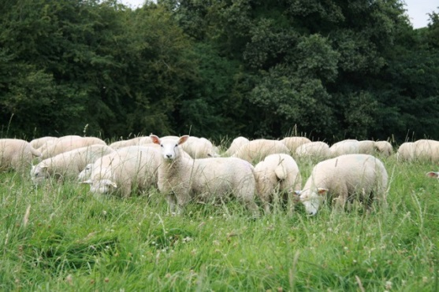The Garton Hardy flock of Lleyn is an outdoor lambing, forage only flock, with breeding pressure to select for ewes that can breed well and keep and regain condition under regenerative grazing techniques from old permanent pastures. A medium sized ewe is targeted, to produce an efficient, low demand system breeding ewe lambs for sale. Selection for worm resistance and unassisted lambing, and an avoidance of triplet bearing ewes is designed to make management simple, stress free and single handed.

**Duncan and Angus Nelless, Northumberland**

Duncan and Angus Nelless farm Thistleyhaugh in partnership with their parents Henry and Enid. It comprises of 1000 acres of owned land on two holdings and 400 acres rented on three FBTs. All land and stock are fully organic. Stock includes 2000 Lleyn ewes, all performance recorded. 550 of the ewes have been part of the RamCompare project over the last 5 years. The flock has been closed to females since 2003. All the main flock is lambed outside. There is also a closed herd of 200 Angus based suckler cows PFLA certified with all calves finished and retained on farm. No concentrates are used for the sheep or cattle.

The brothers also contract rear approximately 1800 outdoor organic pigs per year and rear and process approximately 1400 table birds for Christmas (turkeys, ducks, geese and chickens).

They are very keen on benchmarking, performance recording and peer to peer learning.

**Richard Oglesby, Yorkshire**

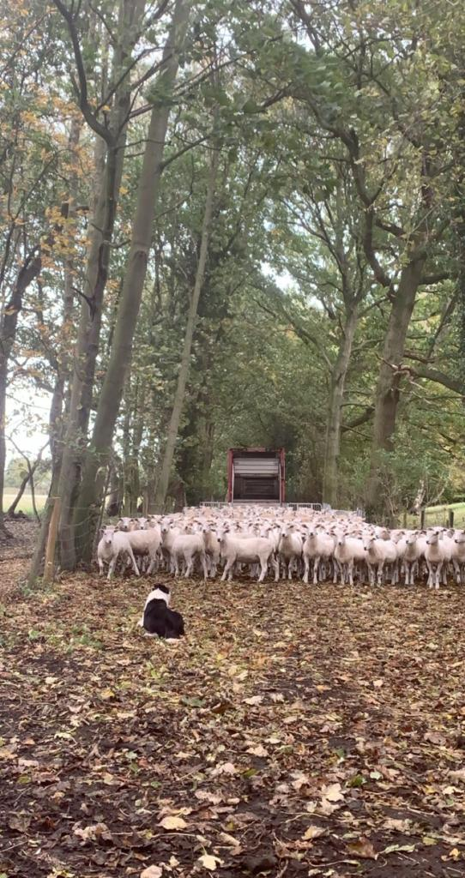

Richard and Jenny farm 1000 ewes in East Yorkshire including 700 pedigree Lleyn ewes, sourced from performance recorded flocks such as flock 1547 (Richard Evans). They plan to start Signet recording next spring aiming to produce high index rams and ewes in the future.

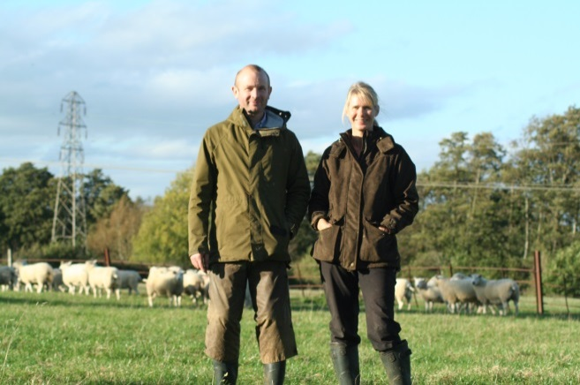**Jason Spence, Gloucestershire**

MV accredited flock of Lleyn sheep established in 2012. Lambing outside in April on a grass based, low input system using the Southdown breed on part of the flock for lambing ease and meat quality, breeding stock for sale and direct meat sales.

**Paul Stead, Oxfordshire**

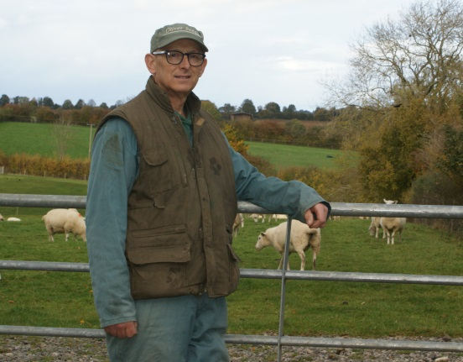Paul has only been breeding Lleyns for a couple of years but has been involved with pedigree sheep for over 10 years and high index animals for 25 years. The Swere Top flock was started by purchases from Marcus Bullock (flock 619) then Manor Farm. We have continued with purchases from Simon Thompson (flock 1448) and Edward Collins flock (981) and this year we made a significant purchase from Richard Evans (flock 1547). It is early days but Paul is aiming to breed sheep that are worm resistant, able to thrive off grass and produce and rear twins with minimal help and no hard feed. He will use Signet, DNA testing and extensive recording via EID to achieve his aims.